Assignment DC Heroes

Date : 11Dec2017

By : Benjamin Porobic ([b.porobic@roc-teraa.nl](mailto:b.porobic@roc-teraa.nl)) & Peter Nocker ([p.nocker@roc-teraa.nl](mailto:p.nocker@roc-teraa.nl))

Hours : 10 hours (4 weeks, 2.5 hours a week)

Assessment : Individual

Read the assignment carefully and ask questions if anything is not clear.

# https://upload.wikimedia.org/wikipedia/commons/thumb/3/3d/DC_Comics_logo.svg/2000px-DC_Comics_logo.svg.pngIntroduction

The founder, Malcolm Wheeler-Nicholson started in 1934 with National Allied Publications, nowadays known as DC Comics. The comics are well-known for their superheroes as Superman, Batman, Wonder Woman, Green Lantern, The Flash, Aquaman and Hawkgirl, including teams such as Justice League, Legion of Super-Heroes and Batman & Robin.

## The assignment

Peter Olsen, DC’s vice president of app development has chosen you as the “web development hero” to create a community website dedicated to DC heroes, called: (how obvious) DC Heroes! This is a wiki website filled with information about different teams and characters. An important feature of “DC Heroes” is the possibility to rate and review every character individually. All the ratings and reviews are stored in the designated table. See chapter “reviews” for more information!

All the characteristics, like name, power, info and path to images are saved and retrieved from the database. The database is divided in different tables (team, hero and rating).

**Note:** the database structure and images will be provided by Peter Olsen. You can download the files from N@tschool.

### The layout

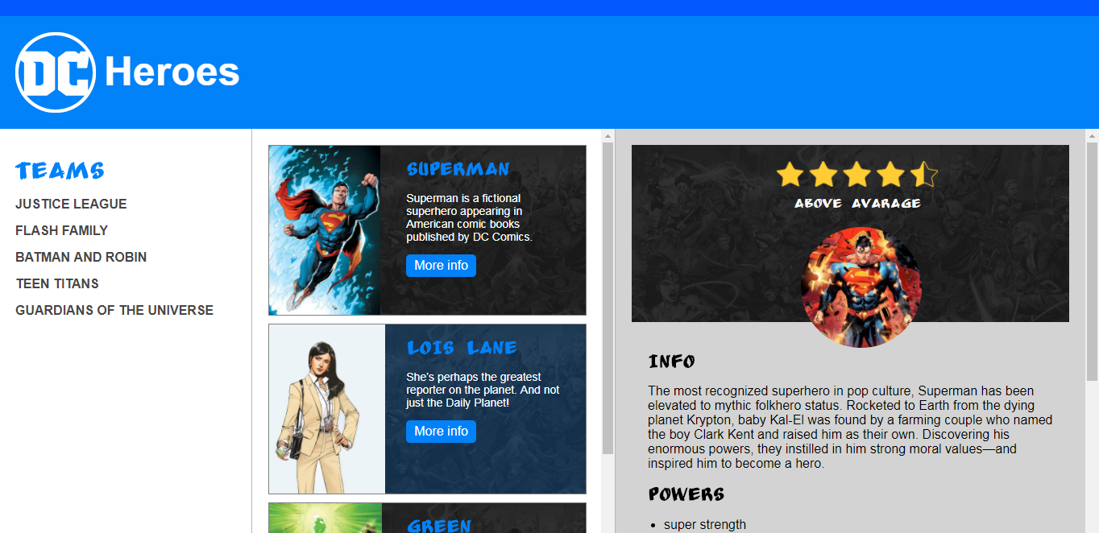

The structure of a website is very important for the User Experience (UX). A great UX makes it easier for visitors to find information they’re looking for. The DC Heroes website is divided in three ‘columns’:

* Left column
  + The main navigation of the website. This is a list with DC teams of your own choice.
* Center column
  + All the characters that belong to a certain team are placed in this column.
* Right column
  + The information about a specific hero will be placed in this column.

### Comment system (Must)

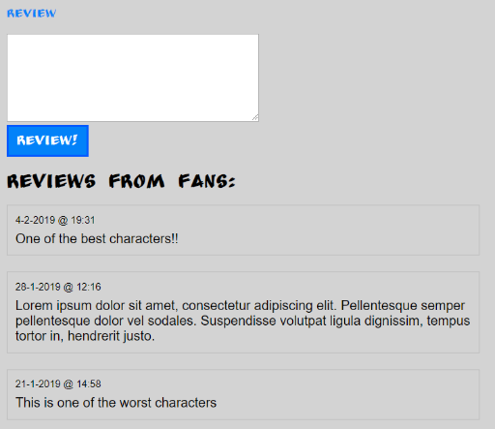The client (Peter Olsen) has a desire for a comment system, with the comment system the users are able to place a message/opinion about each character. The data is fetched from the database, the

newest comments are shown on top.

### Rating system (Should)

The rating is based on a 5-star rating system (one is lowest, five highest) with the possibility to add reviews. The rating score and reviews are stored in the database. Stars are used to show the current rating of a character. With this information, the marketing team can create new merchandise and products.

# Prior knowledge & examples

To successfully complete this assignment, it is necessary to have an understanding of HTML, CSS, MySQL and PHP.

# Requirements (MoSCoW)

## Must 5,5

* Header
  + HTML5 header tag is used to wrap the logo
* Logo with a hyperlink to the homepage
* Navigation (left column)
  + HTML5 nav tag
  + Use a UL for the navigation structure
  + A minimum of 5 teams (fetched from a database)
  + Hover effects
* Heroes (center column)
  + A minimum of 5 heroes for each team
  + All the heroes and their information are fetched from the database
  + Each block consists of the following information: Name of the hero, small description, image and a “More info” button.
  + Alternate background images. Set different background images for even and odd divs.
* Hero Details (right column)
  + All the details are fetched from the database
  + Information: description, path to image, powers
* 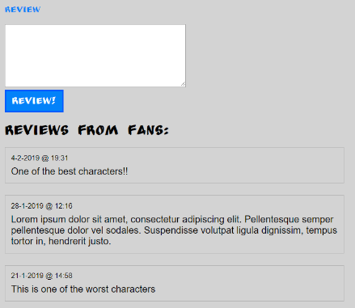Comments system
  + Form with a textarea and a button. The data inside this form will be sent to a database. So all the reviews are saved in a database.
  + Fetch all reviews of a specific character from the database and show them beneath the comments form.
  + Client-Side Form Validation with HTML5. It is important to check if the textarea is not empty before sending the data to the database.
* Github
  + Upload your code regularly to Github
* Coding and structure
  + Organize files neatly in folders
  + Logical and consistent names for variables, id’s and classes
  + Indent code with tabs
* Make a separate file for the database connection and use PHP include to include this file on necessary page(s).

## Should 5,5 – 8

* Rating system
  + Rating based on a 5-star rating system
  + The results are saved in the database
  + Use stars to show the current rating
* Navigation
  + Show a logo in front of the team name
* Navigation
  + 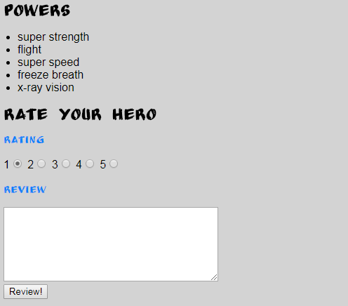Add the number of heroes after the name of the team.
* Favicon
  + Add a favicon

## Could 8 – 10

* API
  + Use an API to retrieve data
* Content Management System (CMS)
  + Create a CMS to add, update and delete heroes

# Won’t

* Use a template or a front-end framework like bootstrap!

Tips & resources

* Use classroom examples and PowerPoint sheets from N@tschool.
* Make backups: external hard drive or cloud storage
* Upload your finished assignment in N@tschool. Use Winrar or 7-zip to pack your files
  + Only .7zip or .rar file extension allowed
  + Filename: ***firstname_lastname_dcheroes.rar***
  + Filename example: john_doe_***dcheroes***.rar

**Reference**

* DC Comic
  + <http://www.dccomics.com/characters>
* API
  + https://comicvine.gamespot.com/api/documentation
  + https://apiaryapib2.docs.apiary.io
* HTML & CSS
  + http://htmlreference.io
  + http://cssreference.io
* PHP
  + <https://www.w3schools.com/Php/php_mysql_intro.asp>
  + https://www.w3schools.com/Php/default.asp

**Courses**

* www.udacity.com
* www.codecademy.com
* [www.freecodecamp.com](http://www.freecodecamp.com)

**Note**

* Work together if necessary, but **do not copy**. **In case of fraud, you have to create your own assignment with the same techniques as this one. You have to discuss this with your teacher!!**

# Assessment

